TABLE OF CONTENTS

Section | Description | Page
1.0 | Our History………………………………………………………………………………………………………………………………………. | 2
2.0 | Our Vision………………………………………………………………………………………………………………………………………... | 2
3.0 | Our Mission……………………………………………………………………………………………………………………………………… | 2
4.0 | Safety……………………………………………………………………………………………………………………………………………….. | 3
5.0 | Our Capabilities………………………………………………………………………………………………………………………………… | 6
6.0 | Recent Projects….…………………………………………………………………………………………………………………………….. | 7
7.0 | List of Past Projects………………………………………………………………………………………………………………………….. | 12
8.0 | Professional Licenses……………………………………………………………………………………………………………………….. | 17
9.0 | Union Affiliations……………………………………………………………………………………………………………………………… | 17
10.0 | Strategic Partners…………………………………………………………………………………………………………………………….. | 18
11.0 | Awards…………………….………………………………………………………………………………………………………………………. | 19
12.0 | References and Letters of Recommendation……………………………………………………………………………………. | 20

“Stefanik’s Next Generation Contracting Co. has constructed numerous projects designed and inspected by Widmer Engineering Inc. over the years. In each case, Stefanik’s Next Generation Contracting Co. has provided the workmanship and expertise that is needed to complete these projects on time and within the budget, including complex projects, no matter what level of expertise that is required.”

-Tony Sedaka, P.E.
Manager
Widmer Engineering, Inc.

1.0 OUR HISTORY

Stefanik’s Next Generation Contracting Company is a second generation company dating back to 1968 that has proudly served the Pennsylvania and Ohio regions. As a second generation company, we continue to maintain existing customer relationships and develop new relationships based on the foundation that this company was founded; Safety, Integrity, Trust, Exceptional Performance, and Quality.
As a proven leader in providing value added construction services, Stefanik’s Next Generation Contracting Company pledges to establish to both our existing clients and our new clients to exceed their expectations through exceptional performance, while never jeopardizing our core value of having zero tolerance to job safety, and to always work in a safe environment.
Today, Stefanik’s Next Generation Contracting Company takes on the role of having the ability and experience to be either the General Contractor (GC) over a project or a subcontractor to the GC.

2.0 OUR VISION

Our vision is to continue our operations on the foundation that it was originally started while having the ability to adapt to an ever evolving construction environment.

3.0 OUR MISSION

Our Mission is to retain and expand our client base by delivering quality service, safely, by delivering the highest quality service on-time and within budget. This is the “Commitment to Excellence” that we guarantee each of our clients.

4.0 SAFETY

Message from the President:
At Stefanik’s Next Generation Contracting Company, our employees and our clients have grown to be family, which is why our most important core value is the safety of our employees, our clients, and the environment. The safe practice of our operations is the foundation to the safety and success of our employees and the company. Each employee at Stefanik’s Next Generation Contracting Company has been empowered to stop work at any time if an employee views something as unsafe.

In addition to maintaining a safe work environment, we pride ourselves in providing our employees with the most current safety training available. At a minimum, our teams follow the following guidelines for each project:
- A routine safety meeting is conducted prior to each shift;
- Inspection of all tools, mechanical and electrical equipment, and safety devices prior to each shift;
- A safety meeting is conducted prior to any work performed if there is a change in field conditions (due to weather or other unforeseen circumstances) or a deviation from the original scope of work;
- All work shall be performed and compliant the most up-to-date training and regulations;
- All employees are to respect each other, the environment, and others.

As President, I will continue to lead this company with the highest regards for safety, including, but not limited to the well-being of our employees, our clients, the public, and the environment.

Sincerely,

__________________________________
Jonathan J. Stefanik
President

The below table represents our Experience Modification Rate (EMR) for the past three years, which includes the number of Total Annual Man-Hours Worked. Furthermore, we have provided a letter from Seubert’s & Associates on Page 5 of this document that identifies our EMR the past five years.

Experience Modification Rate (EMR)

Year | Rate | OSHA 300 Log Total Annual Man-Hours Worked | Declaration Date
2016 | .815 | 43,957 | 10/1/2016
2015 | .806 | 33,873 | 10/1/2015
2014 | .835 | 31,696 | 10/1/2014

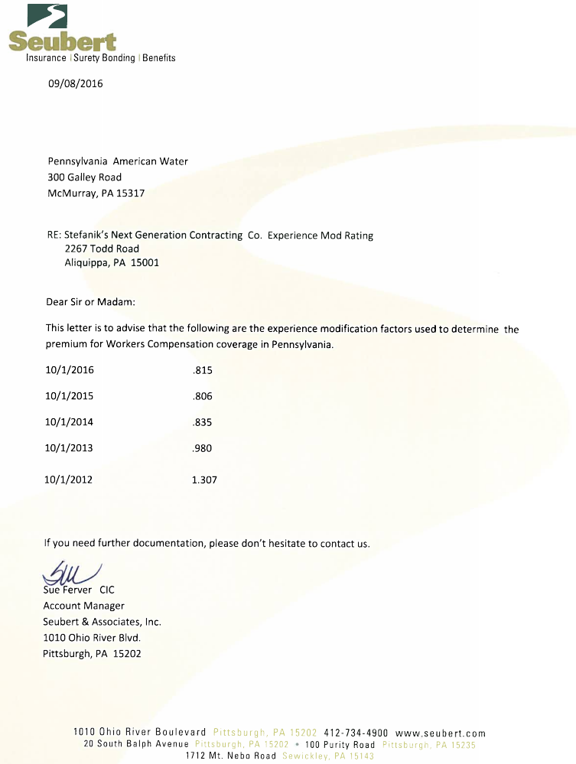
5.0 OUR CAPABILITIES

As the construction industry is ever evolving, Stefanik’s Next Generation Contracting Company aims to provide our clients with world leading services by being able to assemble crews and leadership with the relevant experience that is required to complete our client’s projects on-time and within budget.

We provide a full range of services to the following industries:
- Public
- Private
- Commercial
- Residential
- Penn DOT
- Gas and Oil
- Energy

Our capabilities to the above industries include, but are not limited to the following services:
- Site Demolition
- Utility Demolition
- Installation of Erosion & Sediment Controls
- Land Development/Site Grading
- Installation/Modifications to Underground Utility Infrastructure
  - Stormwater System Piping
  - Underground Detention/Retention Systems
  - Water Conveyance Systems
  - Sanitary Sewer Systems
  - Electrical Conduit/Concrete Duct Bank
  - Pipe Bursting
  - Manhole Rehabilitation
- Bio-Retention Ponds
- Sediment Basins
- Excavation
- Hauling/Disposal
- Hardscape, Softscape, and Landscape

6.0 RECENT PROJECTS

U.S DEPARTMENT OF ENERGY – BUILDING B65 FIRELINE
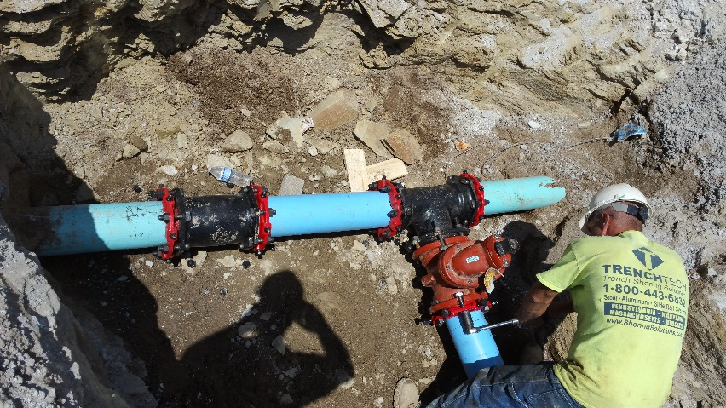 | Year: 2016 / 2017  Work Performed for:  Vantage Corporation  Leanne Pomponio, President  Contract Amount:  $169,274.94
Work Scope:
The project connected an existing water system via ductile iron pipe to the new facility location. Stenfanik’s Next Generation Contracting Company installed a new waterline and appurtenances to support a new gas storage facility on-site, adjust grade for positive drainage, site amenities surrounding the new facility, and restoration of disturbed surfaces.

BRIDGEWATER CROSSINGS – COMMERCIAL / RESIDENTIAL SITE DEVELOPMENT
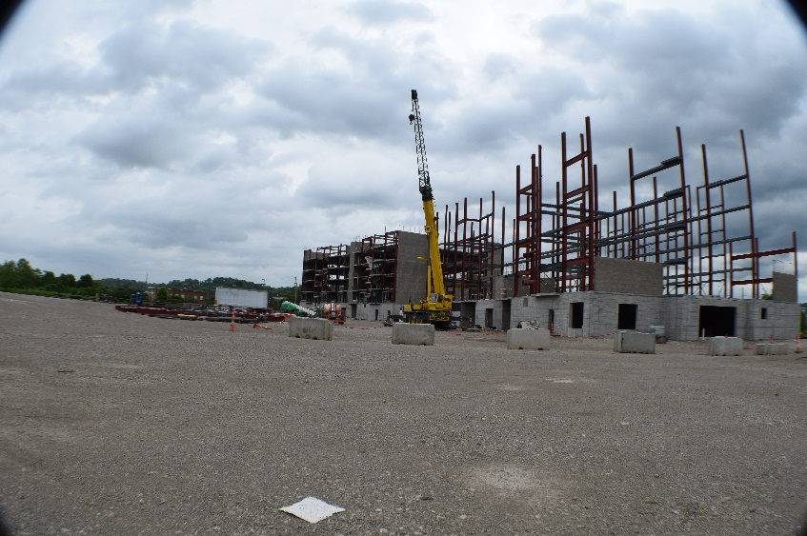 | Year: 2016 / 2017  Work Performed for:  C.J. Betters Builders, LLC  Charles J. Betters, Owner/President  Contract Amount:  $448,680.00
Work Scope:
This project connected (4) new buildings to existing infrastructure in adjacent road ways. Stenfanik’s Next Generation Contracting Company installed site infrastructure (i.e., storm sewer system, water system, sanitary sewer system) for a commercial and residential site development project along the bank of the Ohio River in Bridgewater, PA. The site infrastructure included, but was not limited to: Stormwater and sanitary piping and structures, domestic and fire waterline systems, and appurtenances necessary install complete systems to the new building structures.

CENTER TOWNSHIP WATER AUTHORITY – WATER TREATMENT PLANT
Year: 2015 / 2016

Work Performed for:
Guy’s Mechanical Systems
C.T.W.A.
C. Tucker Cope & Associates
Preload, LLC

Multiple Contract Awards:
Total Contract Value = $3,474,743.00

Work Scope:
The project connected a new water intake system for the proposed treatment plant to support growing infrastructure needs. Stefanik’s Next Generation Contracting Company was awarded several contracts by both the owner and several contractors that included the installation of site stormwater and non-potable/potable water piping systems and appurtenances to support the proposed water treatment plant in Center Twp., PA. Additionally, the scope of work included site grading, stormwater piping and structures, waterline piping, waterline valves and controls, chemical feed lines for treatment, final site grading, sanitary sewer pump station, gravity sanitary sewer, and restoration.

CRANBERRY BEST WESTERN – COMMERCIAL SITE DEVELOPMENT
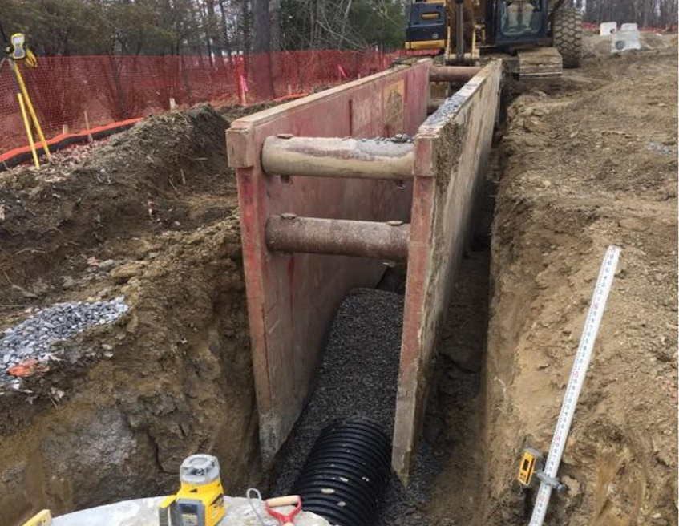 | Year: 2016 / 2017  Work Performed for:  Bear Construction  George Johnson  Contract Amount:  $1,154,044.00
Work Scope:
The scope of work provided site grading and an infrastructure package that included stormwater and sanitary sewer piping and structures, waterline/fire waterline piping and appurtenances, site clearing, and demo.

SCOTT TOWNSHIP POOL REPLACEMENT
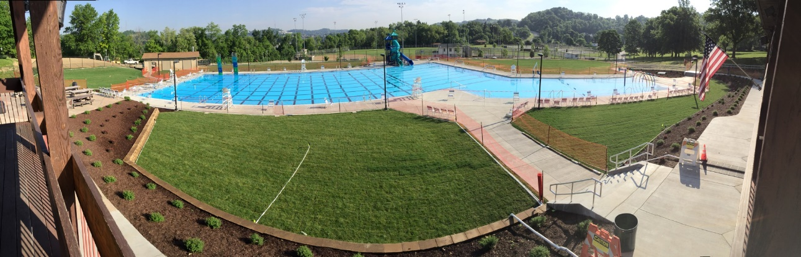 | Year: 2016 / 2017  Work Performed for:  Scott Township Municipal Authority  Randy Lubin, Director of Public Services  Contract Amount:  $1,378,465.00
Work Scope:
Demolish the existing pool and reconstruct a proposed pool at Scott Township Municipal Park, Scott Twp., PA.
Work included the demolition of the existing pool, excavation for the proposed pool structure and piping, new pump house, maintenance building, storm sewer and retention pond, irrigation, concrete pool deck and sidewalks, grading, and lawn installation.

MARONDA HOMES – SANITARY PUMP STATION
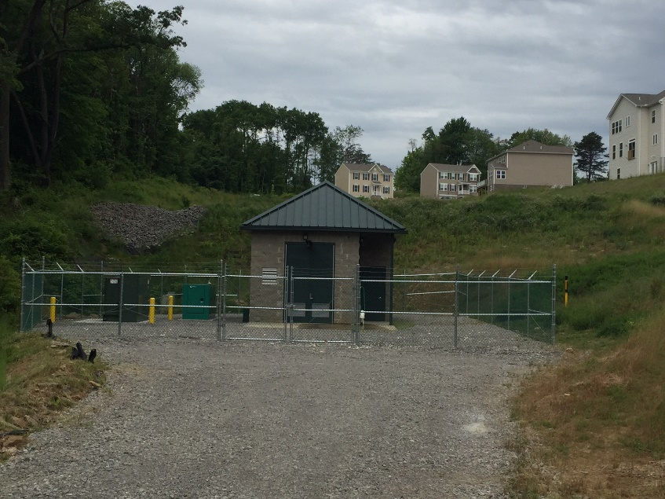 | Year: 2015 / 2016  Work Performed for:  Maronda Homes  Daniel Wolf, Owner  Contract Amount:  $501,700.69
Work Scope:
The scope of work included the construction of the proposed sanitary sewer pump station for a private housing development, site grading and excavation for the building structure, sanitary sewer piping and structures, waterline piping and appurtenances, complete building construction, and pump and interior piping installation.

ETNA GREEN STREETSCAPE – STORMWATER MANAGEMENT AND STREET ENHANCEMENT
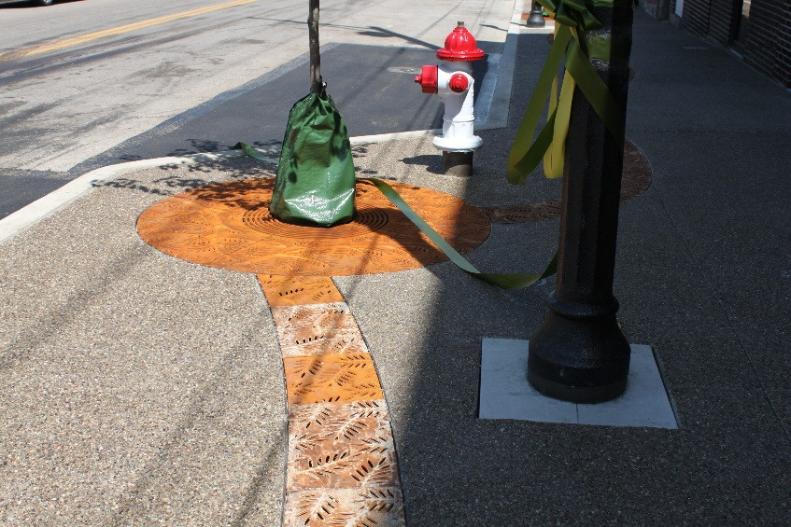 | Year: 2015  Work Performed for:  Boro of Etna  Contract Amount:  $403,841.40
Work Scope:
Installation of proposed stormwater piping, structures and underground detention facilities. Additionally, the scope of work included a new decorative serpentine trench drain in the proposed sidewalk, and a new pave-drain in the parking area in Newrby Alley.

911th AIRLIFT WING – PARKING LOT F
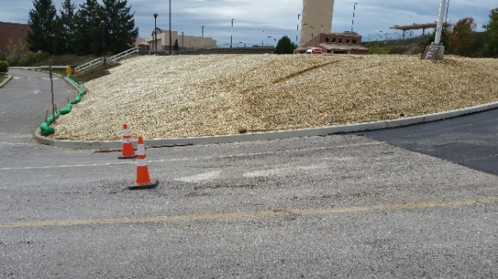 | Year: 2015  Work Performed for:  Spartan Construction Services  Victor Maga, Owner-President  Contract Amount:  $94,654.00
Work Scope:
Work included the demolition of existing amenities, excavation for new site installations, installation of stormwater conveyance systems, aggregate base for new surfaces, and site restoration.

PIERCE BROOK SUBSTATION
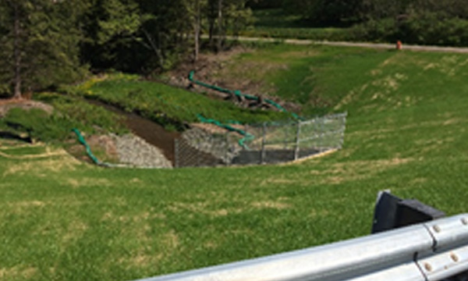 | Year: 2015  Work Performed for:  M. Betters Construction  Mark Betters, Owner - President  Contract Amount:  $1,371,172.59
Work Scope:
Establish site stormwater conveyance system for a new electric substation in Bradford County, PA.
Installation of stormwater piping and structures, erosion and sediment controls, vegetated and rock lined swales, and final site grading and seeding.

BANKSVILLE ROAD CULVERT
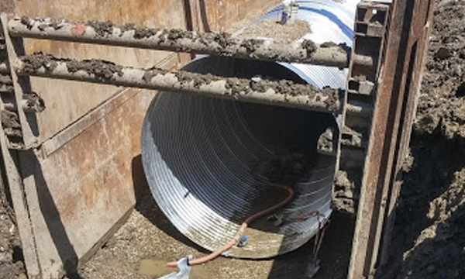 | Year: 2015  Work Performed for:  T.A. Robinson Paving  Tom Robinson, Owner - President  Contract Amount:  $274,503.95
Work Scope:
Demolish and replace approx. 500 lf of 12-foot diameter CMP culvert pipe, remove an existing 12’ diameter CMP culvert pipe and install new 12’ CMP culvert pipe, reconnect existing ancillary piping, aggregate backfill and compaction, and site restoration to grade.

7.0 LIST OF PAST PROJECTS

Name and Address of Owner | Name and Location of Project, Description of work performed | Architect/Engineer | Contract Amount | Name and Address of General Contractor
Center Twp. Water Authority  224 Center Grange Rd.  Aliquippa, PA 15001  Bill Diccicco Jr. | Interim treatment Plant, Mechanical, Electrical, Final Site work and Paving | Lennon, Smith, Souleret Engineering  846 Fourth Avenue  Coraopolis, PA 15108  Contact: Ned Mitrovich  (412) 264-4400 | $ 2,664,535.00 | Guy's Mechanical System  132 Big Knob Rd.  Rochester, PA 15074
Center Twp. Water Authority  224 Center Grange Rd.  Aliquippa, PA 15001  Bill Diccicco Jr. | Interim Treatment Plant Site Grading, Building Lines and Waste Tank Excavation | Lennon, Smith, Souleret Engineering  846 Fourth Avenue  Coraopolis, PA 15108  Contact: Ned Mitrovich  (412) 264-4400 | $ 760,148.00 | Stefanik's Next Generation Contracting  2267 Todd Road  Aliquippa, PA 15001
Scott Township Municipal  301 Lindsay Rd.  Carnegie, PA 15106  Contact: Randy Lubin | Scott Twp. Pool Replacement General Contract | Lennon, Smith, Souleret Engineering  846 Fourth Avenue  Coraopolis, PA 15108  Contact: Larry Lennon Sr.  (412) 264-4400 | $ 1,378,465.00 | Stefanik's Next Generation Contracting  2267 Todd Road  Aliquippa, PA 15001
DPMD, LLC.  3096 Brodhead Road  Aliquippa, PA 15001  Contact: Shawn David | Complete Site Development - Roman Estates | Frye Engineering  211 Gailey Road  Beaver, PA 15009  Contact: Jeff Frye  724-601-1228 | $ 485,000.00 | Stefanik's Next Generation Contracting  2267 Todd Road  Aliquippa, PA 15001
Best Western Plus | Cranberry Twp. PA  Complete Site and site utility development for a new Best Western Plus  Hotel | Penonni Associates  750 Holiday Drive #700  Pittsburgh, PA 15220 | $ 1,154,044.00 | Bear Construction  171 Hillpointe Dr, Suite 101  Canonsburg, PA 15317
First Energy Corporation | Hartville Substation  Substation Expansion including concrete foundations, site grading,  and aggregate surface | First Energy Corporation | $ 184,087.33 | M. Betters Construction  425 Temple Rd.  Monaca, PA 15061  Contact: Mark Betters
Duquesne Light Co.  411 7th Avenue  Pittsburgh, PA 15230 | Ambridge Locust Street  Substation Access Road and Site Mitigation and Drainage | Duquesne Light Co.  411 7th Avenue  Pittsburgh, PA 15230 | $ 41,422.00 | Stefanik's Next Generation Contracting  2267 Todd Road  Aliquippa, PA 15001
First Energy Corporation | Pierce Brook Substation E&S, Storm, Access Roads and permanent seeding | GAI Consultants  385 Waterfront Drive  Pittsburgh, PA 15222  724-772-2011 | $ 1,314,000.00 | M. Betters Construction  425 Temple Rd.  Monaca, PA 15061  Contact: Mark Betters
CJ Betters Builders, LP  100 Bet-Tech Drive  Aliquippa, PA 15001 | Bridgewater Crossing  Site Utilities for a new commercial development | Larson Design Group  300 South Walnut Lane  Beaver, PA 15009 | $ 448,680.00 | Stefanik's Next Generation Contracting  2267 Todd Road  Aliquippa, PA 15001
Pennsylvania Dept. of Transportation | New Castle, PA - CNG Fueling Station  Demolition, Excavation and Grading for a natural gas fueling station | Larson Design Group  300 South Walnut Lane  Beaver, PA 15009 | $ 447,484.26 | Cissell Mueller Construction  5530 Salt River Road  St. Peters, MO 63376
West View Water Authority  210 Perry Highway  Pittsburgh, PA 15229  Contact: George Koleck | Pine Twp. S.R. 910 16" Ductile Iron Waterline Relocation.  Relocate 849 L.F. of 16" Ductile Iron Waterline with  stream crossings in 3 location to allow for widening of bridges. | Bankson Engineers Inc.  P.O. Box 200  Indianola, PA 15051  Contact: Kevin Szachelheidi  412-767-5100 | $ 226,360.00 | Stefanik's Next Generation Contracting  2267 Todd Road  Aliquippa, PA 15001
Borough of Sewickley  910 Thorn Street  Sewickley, PA 15143  Contact: Kevin Flannery | Maple Street Sewer Modifications | KLH Engineers  5173 Campbells Run Road  Pittsburgh, PA 15205  Contact: Shawn Rosensteel | $ 338,000.00 | Stefanik's Next Generation Contracting  2267 Todd Road  Aliquippa, PA 15001
Maronda Homes, Inc.  11 Timber Glen Drive  Imperial, PA 15126 | Clairmont Manor Pump Station | Gateway Engineer  400 Holiday Drive #300  Pittsburgh, PA 15220  412-921-4030 | $ 498,046.00 | Stefanik's Next Generation Contracting  2267 Todd Road  Aliquippa, PA 15001
Borough of Etna  437 Butler Street  Etna, PA 15223 | Etna Green Streetscape | Buchart Horn, Inc.  2200 Liberty Avenue, Suite 300  Pittsburgh, PA 15222  Contact: Don Newman  800-274-2224 | $ 413,453.00 | Stefanik's Next Generation Contracting  2267 Todd Road  Aliquippa, PA 15001
911th Air Wing  at Pittsburgh International Airport  Frank Akers | 911th Air Wing Base.  1,460 L.F. of 6" and 8" Ductile Iron and PVC  Potable Waterline to create closed loop. | United States Air Force In-House | $ 270,491.00 | Spartan Construction Services  580 Achortown Rd.  Beaver Falls, PA 15010  Victor Maga
First Energy Corporation | First Energy of Ohio.  Create closed loop of 2,800 L.F. of 6" and 8"  ductile iron waterline for 4 sites to supply potable  and fire protection water services. | GPD Group  520 South Main St., Suite 2531  Akron, OH 44311  800-955-4731 | $ 403,993.54 | M. Betters Construction  425 Temple Rd.  Monaca, PA 15061  Contact: Mark Betters
Borough of Monaca  928 Pennsylvania Ave.  Monaca, PA 15061  Kurt Digiovine | Monaca Waste Water Treatment Plant.  Install new sewage clarifiers, blowers and 10"  ductile iron blower piping. | Widmer Engineering  806 Lincoln Place  Beaver Falls, PA 15010  Tony Sadaka  724-847-1696 | $ 95,782.04 | Stefanik's Next Generation Contracting  2267 Todd Road  Aliquippa, PA 15001
Beaver County Corporation  for Economic Development  Contact: Laura Rubino | Woodlawn Road Extension. Aliquippa, PA  Cut and fill 19,000 C.Y. of Earth. Installation of  3,900 L.F. of large diameter storm sewer, 20  oversized pre-cast storm structures, 900 L.F. of  8" gravity sewer, 1,800 L.F. of 4" PVC force main,  pump station, 650 L.F. of 16" ductile iron waterline  relocation, cutting in (15) 16" gate valves, (8) 8"  gate valves and 2 fire hydrants. | Michael Baker, Jr.  Road, Earthwork, Storm Sewer Engineer  Widmer Engineering  Water and Sanitary Sewer Engineers  412-269-6300 | $ 605,000.00 | Bet-Tech Construction  100 Bet-Tech Dr.  Contact: Chuck Betters
Allegheny Power  800 Cabin Hill Dr.  Greensburg, PA 15601 | Patterson Sub Station. State College, PA.  Installation of conduit to eliminate overhead  power lines on the exterior of the substation. | In House - Allegheny Power | $93, 460.00 | M. Betters Construction  425 Temple Rd.  Monaca, PA 15061  Contact: Mark Betters
Sebastian Estates  105 Brookhaven Dr.  Aliquippa, PA 15001  Contact: Shawn David | Center Twp., Pennsylvania.  Complete Site Development for 31 Residential Units.  Work Included clearing, earthwork, erosion and sediment  control, storm water management facilities, storm sewers,  sanitary sewer, waterline with 64 domestic and fire connections,  installation of electric telephone and cable conduits. | Hampton Engineering  35 Wilson St., Suite 201  Pittsburgh, PA 15223  724-625-4544 | $ 470,268.00 | Stefanik's Next Generation Contracting  2267 Todd Road  Aliquippa, PA 15001
Scott Township Municipal  301 Lindsay Rd.  Carnegie, PA 15106  Contact: Randy Lubin | Twp. of Scott Year 1, 2, 3, 4, 5 - Sanitary Sewer Repairs - 94 open cut sewer repairs and 35 new manholes installed. | Lennon, Smith, Souleret Engineering  846 Fourth Avenue  Coraopolis, PA 15108  Contact: Ned Mitrovich  (412) 264-4400 | $ 1,715,000.00 | Robinson Pipe Cleaning 2656 Idlewood Rd. Pittsburgh, PA 15205
Center Twp. Water Authority  224 Center Grange Rd.  Aliquippa, PA 15001  Bill Diccicco Jr. | Center Twp. Road Repairs 2006, 2007, 2008, 2009 Center Twp., Beaver County - Approx. 1,300 sq. yards of asphalt restoration on Twp. And state roads. | Lennon, Smith, Souleret Engineering  846 Fourth Avenue  Coraopolis, PA 15108  Ned Mitrovich  (412) 264-4400 | $ 260,000.00 | Stefanik's Next Generation Contracting  2267 Todd Road  Aliquippa, PA 15001
Ambridge Water Authority 600 11th Street Ambridge, Pa 15003 | New Martin Way Waterline and Pressure Regulator Vault - 520' of 8" water main, pressure of reducing vault and all restoration | NIRA Consulting Engineers Inc.  950 5th Avenue  Coraopolis, PA 15108  Contact: Frank Lemmon | $ 115,000.00 | Stefanik's Next Generation Contracting  2267 Todd Road  Aliquippa, PA 15001
Giant Eagle, Inc.  6511 Steubenville Pike  Carnegie, PA 15106 | Rochester Get-Go Storm Sewer Relocation - 230' of 30" storm line, 95' of bore and jack under route 65 including all manholes and restoration. | Lennon, Smith, Souleret Engineering  846 Fourth Avenue  Coraopolis, PA 15108  Larry Souleret  (412) 264-4400 | $ 137,464.00 | Sunpro Inc. 7640 Whipple Ave. N.W. North Canton, OH 44720
Freedom Area School District | Site and Utility Construction for New ADA Restrooms - 640 LF of 8" Sanitary Sewer Main including all manholes and restoration. | Mazza Engineering Associates Inc.  Eugene Mazza  236 Center Grange Rd  Aliquippa, PA 15001  724-728-8110 | $ 68,350.00 | Stefanik's Next Generation Contracting Co. 117 Christy Dr. Monaca, PA 15061
Borough of Sharpsburg | Installation of manholes, replacement of storm inlets and sanitary point repairs. | Glenn Engineering - Randy Zischau  14920 Lincoln Hwy  North Huntingdon, PA 15642  412-824-5672 | $ 125,000.00 | Robinson Pipe Cleaning 2656 Idlewood Rd. Pittsburgh, PA 15205
Borough of Blawnox | Manhole casting replacement and installation of manholes. | Senate Engineering Rich Knapic  420 William Pitt Way  Pittsburgh, PA 15238  412-826-5454 | $ 55,583.00 | Robinson Pipe Cleaning 2656 Idlewood Rd. Pittsburgh, PA 15205
City of Warren, OH | Locate and raise manholes, assist rehabilitation contractor with sewer rehabilitation work. | URS Akron  Ron Black  564 White Pond Dr # A  Akron, OH  330-836-9111 | $ 130,000.00 | Robinson Pipe Cleaning 2656 Idlewood Rd. Pittsburgh, PA 15205
Borough of West View | Various locations, Sanitary Point Repairs. | Glenn Engineering - Randy Zischau  14920 Lincoln Hwy  North Huntingdon, PA 15642  412-824-5672 | $ 91,000.00 | Robinson Pipe Cleaning 2656 Idlewood Rd. Pittsburgh, PA 15205
Ambridge Water Authority  600 11th Street  Ambridge, Pa 15003 | 6th Street Waterline Replacement, 850' of 8" duct pipe including all valves and fitting restoration | NIRA Consulting Engineers Inc.  Frank Lemmon Jr.  950 5th Avenue  Coraopolis, PA 15108  412-262-3970 | $ 174,000.00 | Stefanik's Next Generation Contracting  2267 Todd Road  Aliquippa, PA 15001
Coraopolis Water & Sewer Authority | Orchard and Stratford Ave. | Lennon, Smith, Souleret Engineering  Ned Mitrovich  846 Fourth Avenue  Coraopolis, PA 15108  (412) 264-4400 | $ 180,129.00 | Stefanik's Next Generation Contracting  2267 Todd Road  Aliquippa, PA 15001

8.0 PROFESSIONAL LICENSES

Licensing State | License Description | License No.
Ohio | Section 3737.65, Ohio Revised Code for servicing, testing, repairing, and installing fire protection for firefighting equipment. | 53 89 1746
Pennsylvania | Pennsylvania Department of Transportation Contractor Pre-Qualifications Work Class Codes:  C1: Other Excavation and Grading (Roadways Patches, Drainage, Structure Related, etc.);  C3: Geotextiles;  H: Drainage, Water Main, Storm Sewer;  H1: Pipe and Culvert Cleaning;  H2: Pavement Base Drains;  M2: Silt Barrier Fence, Gabions, Erosion Control | BP-005354

9.0 UNION AFFILIATIONS

Agreement | Expiration Date:
Laborers’ District Cancel of Western Pennsylvania Contract No. 40280 | 12/31/2017
Laborers’ District Cancel of Western Pennsylvania Contract No. 40200 | 12/31/2017
Laborers’ District Cancel of Western Pennsylvania Contract No. 40203 | 12/31/2017
Local Union No. 66 International Union of Operating Engineers Building Construction Agreement | 05/31/2017
Local Union No. 66 International Union of Operating Engineers Building Construction Agreement | 12/31/2017

10.0 Strategic Partners

Spartan Construction Services
Beaver Falls, PA
Guy’s Mechanical Systems
Rochester, PA

PDDM Solutions, LLC
Pittsburgh, PA
Engle Design, LLC
Center, PA

11.0 Awards

Awards
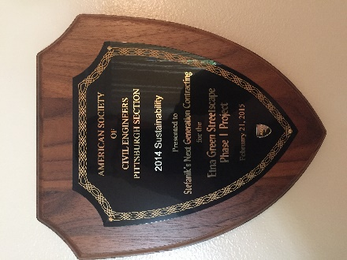 | Presented by: American Society of Civil Engineers, Pittsburgh Section  2014 Sustainability for the Etna Green Streetscape Phase I Project, dated February 21, 2015
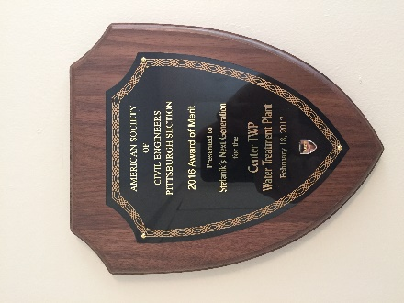 | Presented by: American Society of Civil Engineers, Pittsburgh Section  2016 Award of Merit for the Center TWP Water Treatment Plant, dated February 18, 2017

12.0 REFERENCES AND LETTERS OF RECOMMENDATION
